There’s some directional terms we use in anatomy. I’ll list them below with respect to the skull foramina to assist you with what you are looking at  
Superior= above (looking down into the cranial cavity once the brain is moved)  
Inferior= below (this would be a base view of the skull)  
Anterior= front (towards the face)  
Posterior= back   
Lateral= to the side of the body  
Medial= towards the middle (towards the sagittal plane- the line that divides the body into a Left and Right)  
  
Some important landmarks:  
Occipital condyles (base of head: inferior view)  
Sella turcica (superior view and medial depression/groove where the pituitary gland is located)  
  
This is the list of holes the students must know and what runs through them that they are also responsible for knowing.

Foramina, Canals, Fissures (note: Roman Numeral represents number assigned to the 12 pairs of cranial nerves)

A. **carotid canal** (carotid arteries)   
*Note: best seen from inferior view (base of skull)*

B. **olfactory foramina** (olfactory nerve; Cranial Nerve l), aka cribriform foramina   
*Note: superior view*

C. **optic canal** (optic nerve; Cranial Nerve II)   
*Note: Superior view but best seen in eye socket*

D. **superior orbital fissure** (oculomotor nerve Cranial Nerve III, trochlear nerve Cranial Nerve IV, abducens nerve Cranial Nerve VI, trigeminal nerve Cranial Nerve V-ophthalmic branch)   
*Note: Superior view but best seen in eye socket*  
Note 2: Some text list ophthalmic as V1

E&F. **foramen ovale** and **foramen rotundum**   
(trigeminal nerve Cranial Nerve V-maxillary and mandibular branches)   
*Note: Foramen rotundum can only been seen superior.* F. Ovale can be seen from superior and inferior  
Note 2: Some text list maxillary as V2 and mandibular as V3

G. **internal auditory canal, aka internal acoustic meatus** (facial nerve CN VIl, vestibulocochlear nerve CN VIII)   
*Note: Superior view only*  
  
H. **external acoustic meatus, aka external auditory canal**   
*Note: Lateral view only*

I. **jugular foramen** (glossopharyngeal nerve CN IX, vagus nerve CN X, accessory nerve CN XI, jugular veins)  
*Note: Superior and inferior view*

J. foramen magnum (accessory nerve CN XI, spinal cord, vertebral arteries)

*Note: Superior and inferior view*

K. foramen lacerum (blood vessels)  
*Note: Superior and inferior view*

L. foramen spinosum (blood vessels)  
*Note: Superior and inferior view*

M. hypoglossal canals (hypoglossal nerve CN XII)  
*Note: Superior and inferior view*

N. stylomastoid foramen (facial nerve CN VII)  
*Note: Inferior view only*

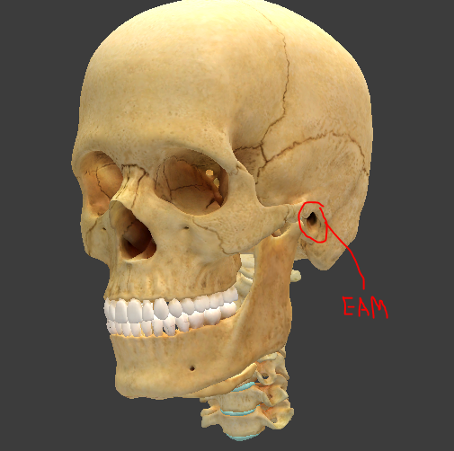

External Auditory Meatus (aka External Acoustic Canal) can only be seen from a lateral view

